HR Analysis Report

Project Title:
HR Analytics Dashboard using Power BI
Dataset Information
- Dataset Name: HR Analytics
- Total Records: 22,214
- Total Columns: 13
- Tool Used: Microsoft Power BI

Submitted by: Vishanth M S
KPI | Value
Total Employees | 1000
Remote Employees | 250
Headquarters Employees | 750
Remote Workers (%) | 25%
Headquarters Workers (%) | 75%
Average Employee Age | 38.55 Years

Visualizations Created:
- KPI Cards:
- Total Employees:
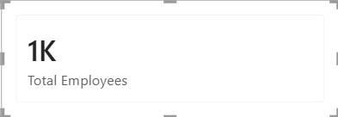

- Remote Employees:
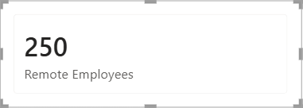

- Headquarters Employees:
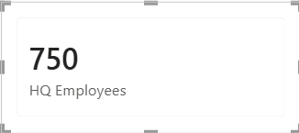

- Remote Workers (%):
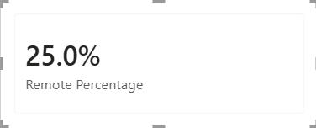

- Headquarters Workers (%):
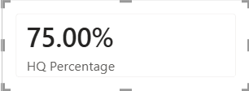

- Average Employee Age:
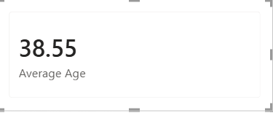

- Hiring Rate by Year (Line Chart)
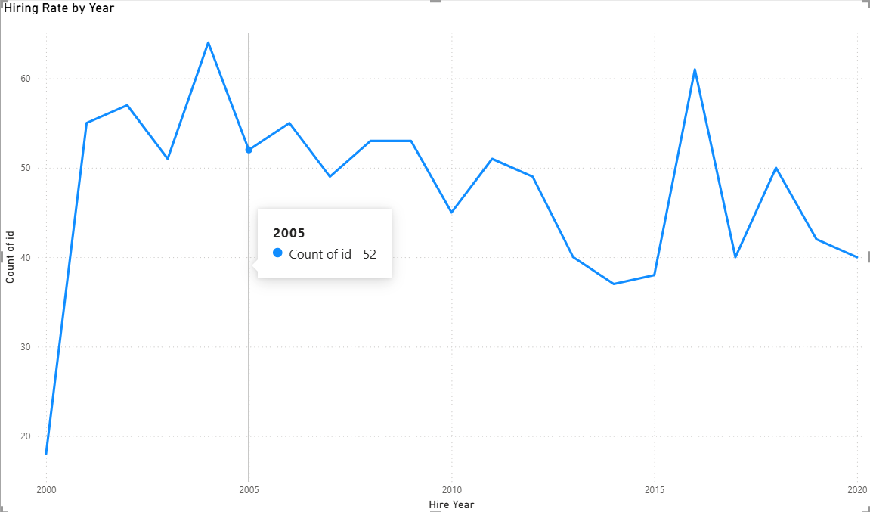

- Gender Distribution (Donut Chart)
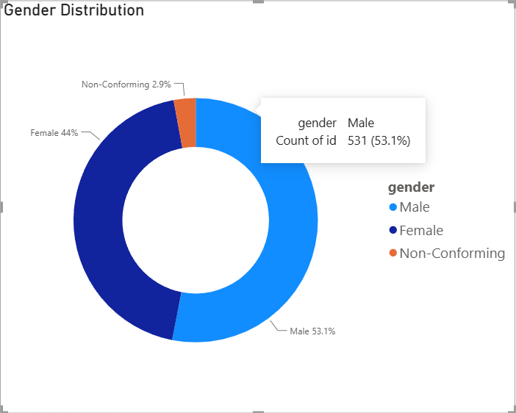

- Employees by State (Bar Chart)
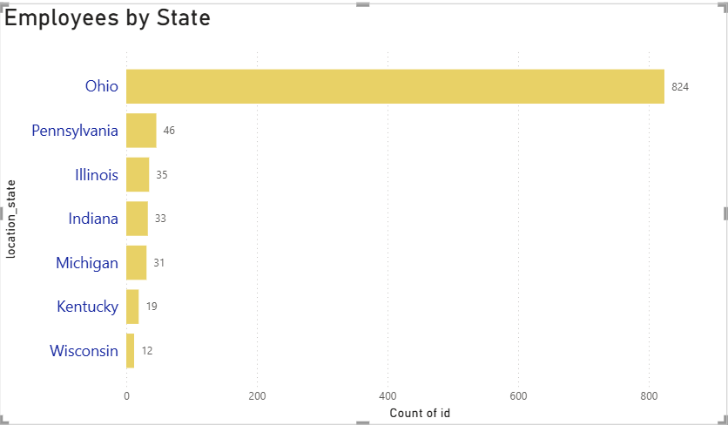

- Employees by Department (Bar Chart)
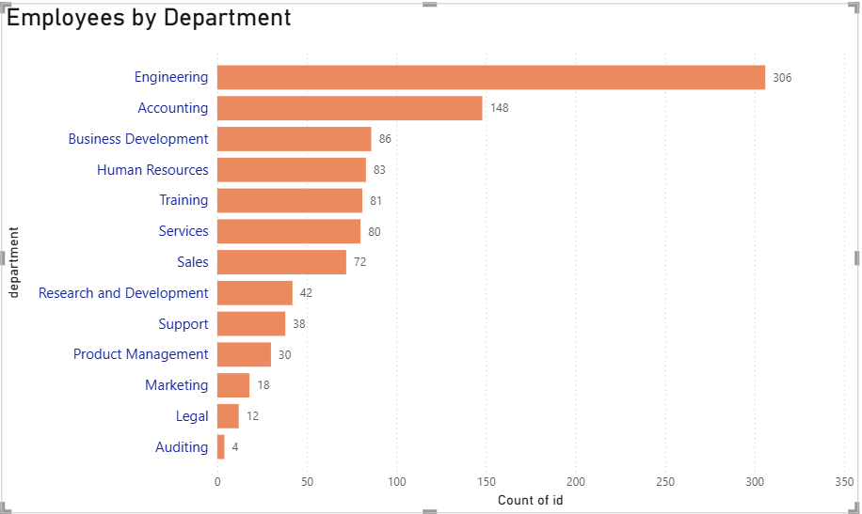

- Employees by Race (Bar Chart)
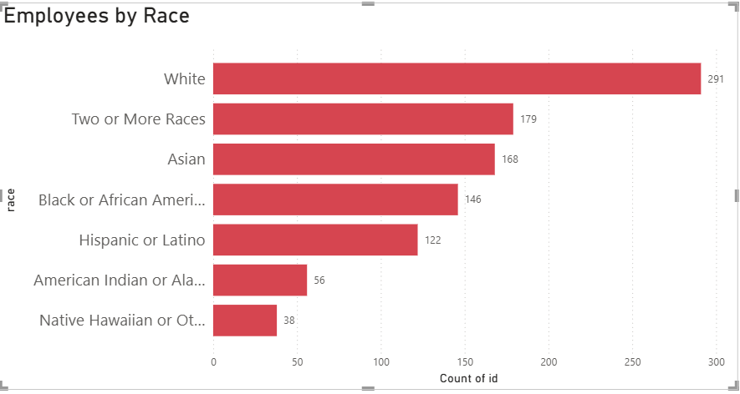
Business Insights:
- The organization has 1000 employees.
- The average employee age is 38.55 years.
- 25% of employees work remotely.
- 75% work from headquarters.
- Engineering is the largest department.
- Accounting is the second-largest department.
- Ohio has the highest number of employees.
- The workforce has a good gender balance, with a slight male majority.
- The company has employees from multiple racial backgrounds, indicating diversity.
Recommendations:
- Increase workforce diversity through targeted recruitment.
- Expand hiring in underrepresented locations.
- Continue monitoring remote work policies.
- Strengthen employee engagement initiatives.
- Use HR analytics for strategic workforce planning.
Conclusion:
Power BI helped visualize workforce demographics, hiring trends, departmental distribution, and employee diversity. These insights enable management to make informed decisions regarding recruitment, workforce planning, and organizational growth.

